8/5/14

Dear *****

Welcome to the EMS District 9 201* ***** course. This packet is intended to offer you information on the course expectations, the pre-reading that is required, the course schedule and online access to course resources. I am really looking forward to meeting all of you and getting started with our course.

- Your course schedule - Enclosed with this packet is your current course schedule. Please note that as the class progresses, there may be some changes to the schedule. We will discuss these as a group and new schedules with updated dates and topics will be provided to you electronically.

- Your textbook and workbook – You will find your book and workbook at the back of this packet. (Unless you have received it earlier) Please note that chapters 1-3 and chapter 5 are required pre-reading for the course. We will be referring to the content in these chapters during different parts of the course and some of the content may be on your final exam. You are responsible for reviewing this material.

- Your online access - I have created an online classroom for us to use for various portions of the course. You will find electronic versions of the course schedule here, additional study resources, make up work etc. Also located here is the pretest that is required for this course. Please log in to the site (Instructions follow on a separate page) and complete this pretest prior to August 19th. I have allotted 2.5 hours for the test, but there are only 65 questions. The questions are from the EMT curriculum to assess your baseline knowledge.

- Course Expectations - Please review the course expectations document and let me know if you have any questions.

- Course Location- As a reminder, the course will be held at the **********. The station address is *************, VT. The station phone number is 802-***-****. Directions are included.

Finally, our class begins at 6pm on *************. We will jump right in with the chapters as this will be a fast paced course. Again, I look forward to working with all of you over the next few months. If you have any questions, please do not hesitate to contact me by phone or email.

Thanks and see you soon –
**********************

Name, Credentials
Title
Organization
802-***-****
email

REMINDER: Pre-reading to be completed prior to 8/21/14

Please do review chapters 1-3, and 5 in your text prior to the start of class. Please let me know if you have any questions.

Please log in to the online course site and complete the pre-test prior to August 19th.

Online Access to Course Resources

We will be using a learning platform named Haiku learning. This is an online resource that will allow us to track attendance, tests, and offer you resource links etc. If you do not have reliable internet access, please let me know at the first class and will be discuss options.

The website address is a bit long, so I recommend bookmarking it for easy use in the future. Each of you have an individual code to allow access.

https://www.myhaikuclass.com/mariahc73/aemt/signup

Once you go to this sign up page, enter your individual 5 digit code (you code is on the haikulearning page after this section – ignore the parent code)
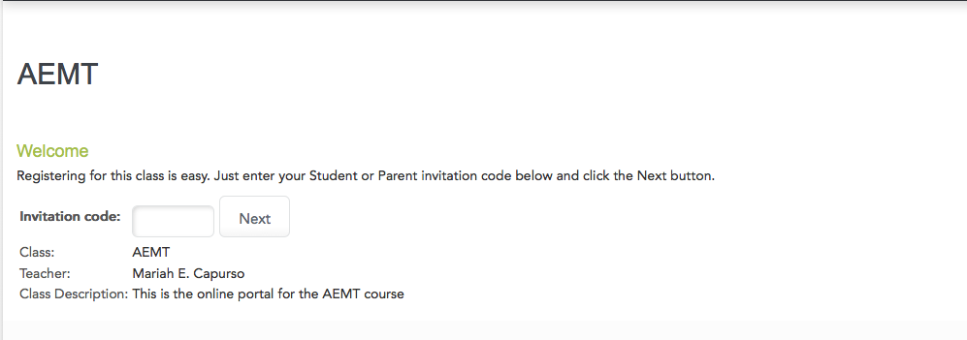

Click next – this will bring you to a login screen.
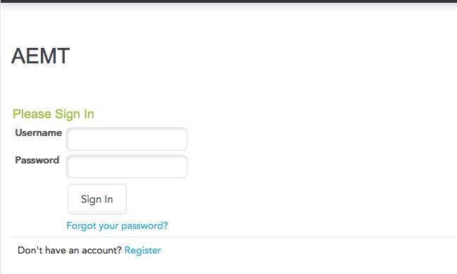
Click on the Register link at the bottom
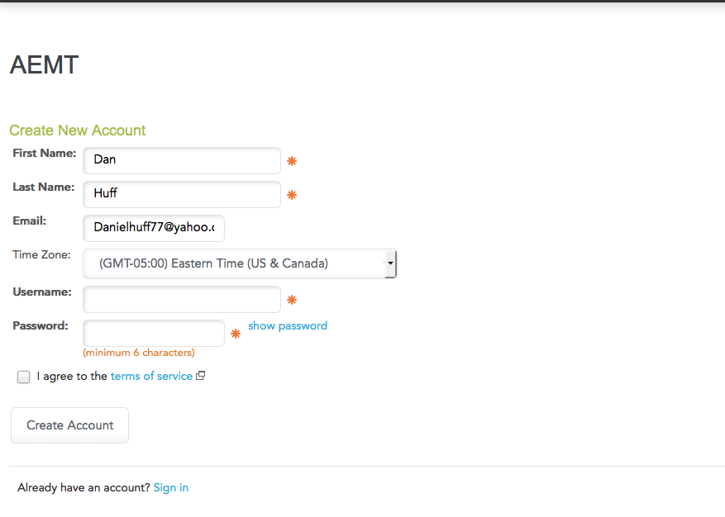

Complete the form. Now you have your login and password that you will use throughout the course.

Any questions? Please email me.
Course Expectations

What you can expect from me as your instructor:
- I will be on time for all classes
- I will be prepared to lead discussions
- I will have appropriate supplies and equipment available for each practical session
- I will arrange for additional instructors for practical sessions
- I will respond to your feedback in a timely fashion
- I will grade all quizzes, homework, exams within 1 week of receiving it so you have timely feedback on your work
- I do want your honest feedback of both my teaching style and that of any guest instructors
- I will notify you of any class cancellations or changes at least 4 hours prior to class except in the case of an emergency.
- I will provide you with fair and honest feedback of your work and practical skills
- I will encourage you to learn as much as you can during the course
- I will provide you with tools and resources to add to your learning
- I will treat all of my students with respect

What I expect from you as a student:
- I expect you to be on time for classes unless you have arranged a later start with me prior to the class
- I expect you will let me know if you need to miss a class in advance except in the case of an emergency
- I expect you to make up all missed classes
- I expect you to complete all clinical requirements for the course prior to requesting to take the written exam
- I expect you to be adequately prepared for class
- I expect you to treat each other with respect
- I expect you to communicate with me if you are struggling with the material or having another issue that is impacting your ability in the course.

Directions to the *************

From Interstate 91

Take exit 14 and travel west on route 113 towards Thetford Hill and Thetford Center.

You will travel approximately 2 miles and the fire station will be on your left just after the elementary school.

